SIMPLE HEALTH CAMP REGISTRATION SYSTEM
@CREATIVITY THINK (9483175986/7019689991)

ABSTRACT:
Simple Health Camp Registration System is a web-based platform designed to streamline the registration, scheduling, and management of health camps organized by hospitals, NGOs, colleges, and community centers. The system allows users to browse upcoming health camps, register for available time slots, receive confirmations and instructions, and view basic health metrics post-camp. Administrators can create camps, define services, manage participant slots, record attendance, and monitor summarized health data. Developed using Django and Django REST Framework for backend services, and React with react-table and axios for frontend interactivity, the platform ensures efficient camp organization, accurate participant management, and insightful analytics..

INTRODUCTION OF THE PROJECT:
Organizing health camps requires careful planning, participant management, and accurate record-keeping. Manual registration processes and paper-based tracking often lead to errors, inefficient scheduling, and incomplete health data. The Simple Health Camp Registration System addresses these challenges by offering a centralized, digital solution that enables online registration, slot management, basic health record tracking, and dashboard analytics. Users and administrators benefit from a structured workflow, real-time data updates, and improved operational efficiency..

PROJECT OBJECTIVES:

• Provide a digital platform for listing and managing upcoming health camps
• Enable participants to register for specific time slots online
• Send confirmation notifications and participation instructions to users
• Record and summarize basic health metrics post-camp (e.g., BP, weight)
• Allow administrators to define camp services and manage participant slots
• Offer dashboards with participant statistics, age distribution, and attendance trends
• Export participant logs and reports for further analysis
• Reduce manual administrative workload and improve scheduling efficiency
• Enhance participant experience and camp effectiveness

PROBLEM OF THE STATEMENT:
Manual management of health camps often results in registration errors, scheduling conflicts, incomplete participant data, and difficulty tracking health metrics. Without a centralized system, administrators struggle to organize camps efficiently, and participants face uncertainty regarding available slots and camp details. The Simple Health Camp Registration System solves these problems by providing a digital solution that streamlines registration, attendance, and basic health tracking while offering analytical insights for better planning and management..

MOTIVATION OF THE PROJECT:
• To automate the registration and slot management process for health camps
• To provide real-time availability and reduce scheduling conflicts
• To maintain structured records of participants and their basic health metrics
• To offer administrators insights via dashboards and analytics
• To generate reports for documentation and future planning
• To improve participant experience through notifications and structured workflows
• To reduce manual errors and administrative workload
• To enhance operational efficiency for health camp organizers

BLOCK DAIGRAM OF PROJECT:

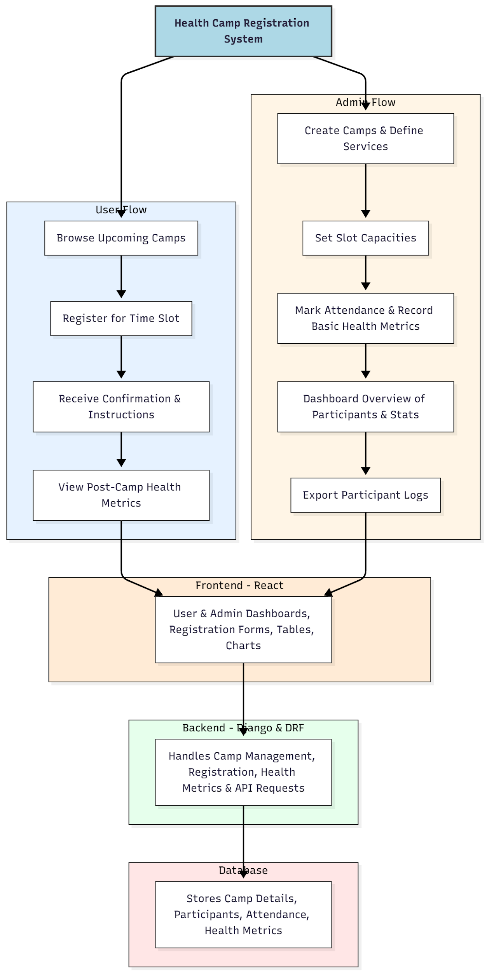

WORKING OF THE PROJECT:
Users access the portal to browse upcoming health camps and register for available slots. Upon registration, participants receive confirmation notifications and instructions. Post-camp, users can view a summary of their recorded health metrics. Administrators create and manage camps, define services, set slot capacities, mark attendance, and record basic health readings. Dashboards display participant statistics, age groups, and other key insights, while detailed participant logs can be exported for further analysis. The backend manages all API requests, data storage, and real-time updates on the frontend, ensuring an organized, reliable, and user-friendly system..

SOFTWARE REQUIREMENT:
- Backend:
  - Python 3.x
  - Django
  - Django REST Framework
  - SQLite/PostgreSQL
- Frontend:
  - Node.js and npm
  - React.js
  - Axios
- Development Tools:
  - Visual Studio Code
  - Postman (for testing APIs)
  - Git/GitHub (for version control)
- Server/Deployment (Optional):
  - Gunicorn, Nginx, or Heroku/AWS for hosting

ADVANTAGES OF THE PROJECT:

• Streamlines registration and slot management for health camps
• Provides real-time participant tracking and health metrics
• Reduces manual workload and scheduling errors
• Offers dashboards with summarized statistics and analytics
• Enables easy export of participant logs and reports
• Improves participant engagement and satisfaction
• Provides structured, organized records for future planning
• Scalable for multiple camps and diverse user groups

APPLICATIONS OF THE PROJECT:
• Hospitals and healthcare providers
• NGOs and community health initiatives
• Colleges and universities
• Corporate health camps
• Local community centers and social health events

REFERENCES:

- Django REST Framework Documentation — Django Software Foundation. Django Documentation. Available: https://docs.djangoproject.com/
- Django REST Framework. DRF Documentation. Available: https://www.django-rest-framework.org/
- React. React Official Documentation. Available: https://reactjs.org/docs/getting-started.html
- Redux. Redux Documentation. Available: https://redux.js.org/introduction/getting-started
- PostgreSQL Global Development Group. PostgreSQL Documentation. Available: https://www.postgresql.org/docs/
- MySQL. MySQL Reference Manual. Available: https://dev.mysql.com/doc/
- Git. Git Documentation. Available: https://git-scm.com/doc
- Node.js. Node.js Documentation. Available: https://nodejs.org/en/docs/
- Axios. Axios Documentation. Available: https://axios-http.com/docs/intro
- Socket.io Documentation – https://socket.io/docs/

